5.34: Since the speed is constant and we are neglecting air resistance, we can ignore the 2.4 m/s, and in the horizontal direction must be zero. Therefore 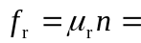 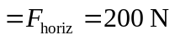before the weight and pressure changes are made. After the changes, 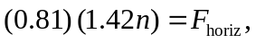 because the speed is still constant and 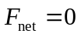. We can simply divide the two equations:
